Newsletter from the Archbishops.
Bicentenary Tuia



Tena koutou - Malo Elelei - Vinaka - Talofa lava - Welcome

Greetings for this new year of 2015.
This is the first edition of a quarterly newsletter with an aim to 'stay in touch' and to outline the work we undertake as the primates across Aotearoa, New Zealand and Polynesia. We hope to be able to share our thoughts and experiences and so add to the work that is already done through the Taonga website and magazine. The email form means it can be easily forwarded to others who may be interested, so please distribute it widely.

We celebrate in the past week that Archbishop John Dew of Wellington and Bishop Soane Patita Paini Mafi of Tonga are among the 15 new cardinals named by the Pope. Our prayers and the best wishes of the Province go to both of them in their new responsibilities.

In this season of Epiphany, be assured of our prayers

++ Brown, ++Philip, ++Winston

The Rev'd Riwai Preece

The Archbishops note with sadness and with prayers, the death of the Rev’d Riwai Preece. He was Priest in Charge of the Chatham Islands, part of the Diocese of Christchurch.
Riwai served as Priest in Charge of the Maori Mission in Christchurch in 1987 before taking up the role in the Chatham Islands in 1988. Riwai, and his whanau, were from the Chathams, and are prominent members of the community there.
Archbishop Brown remembers Riwai fondly, saying "When you were in the Chathams and in Riwai's presence, you felt grounded and connected through him, and safely cared for. He was a faithful and durable priest, and he will be sadly missed by all."
Riwai's whanau is known beyond the shores of the Chathams. Riwai's brother, Alfred Preece, was a member of the 28 Māori Battalion, and was present at most of the Battalion's subsequent reunions and events following the War. Alfred was also present at the November 2014 opening ceremony for the C Company Memorial House in Gisborne. We know that Alfred and the extended whanau will be deeply saddened at the loss of Riwai.
The Archbishops give thanks for the life of Riwai, and our prayers are with his whanau and the wider community of the Chatham Islands, and the Diocese of Christchurch at this time.

  IN THIS ISSUE:
  • Reflections on Oihi
  • Pasefika voices at the G20
  •Trans-tasman Primatial talks
  Archbishop Brown asks where was Ruatara at the Bicentenary Service on Christmas Day
  Archbishop Winston at G20 Conference
  "We are here, because the leaders of the world are here. It is about action. Not tomorrow. Today!"
  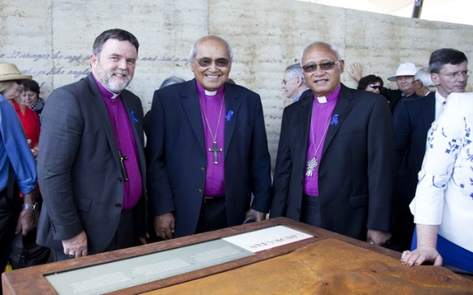
  Gathering at Oihi - 200 years on
  Oihi was a pilgrimage on both December 21st for the opening of Rangihoua Heritage Park and then a few days later for the Christmas Day Service
  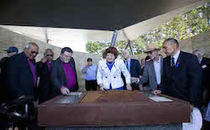

FROM THE ARCHBISHOPS
  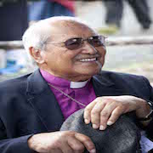
  On Oihi 2014
  "The picture of Christmas 2014 at Oihi would not have been visualised by our predecessors - the changing faces of a constant gospel message"
  "I was left thinking where was Ruatara"
  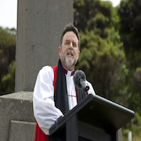
  Sermon at Oihi
  "It is also important to acknowledge that this historic moment in 1814 was many years in the making and to acknowledge that its potential is still to be fully realized.
  This moment two hundred years ago was possible because of grace – filled generosity."
  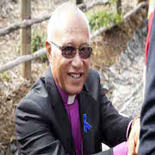
  At the G20 in Brisbane
  "For some of us from the Pacific Island states, the truth is as plain as writing on a wall: our land and livelihood are drowning while others refuse to see"
  "How can we say to our grandchildren the home you were to inherit and told about is destroyed. Where is justice for them and for others?"

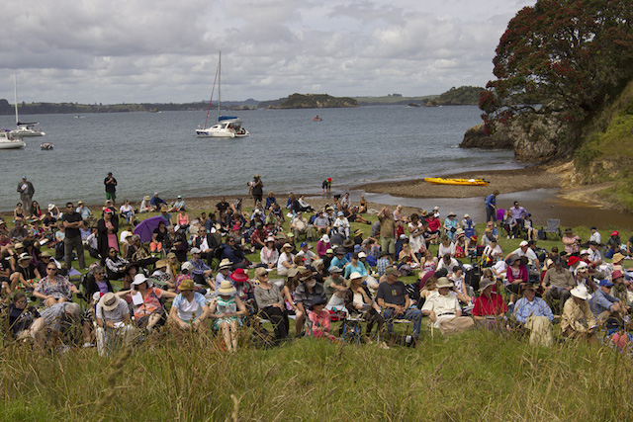
Where is Ruatara?
A strong image for me from Christmas Day at Oihi was a sea of white faces that were gathered on the grass and foreshore. Some were nearby and others were on boats and on the side of the surrounding hills. We do not have the actual pictures of 1814, but I am sure it was a different picture two hundred years ago; then it was a sea of brown faces and the white faces would have been very limited.

The images of two hundred years ago and of today leave more to think about. As I consider the people that gathered in 2014 I am sure a lot of the white faces in front of me had Maori blood in them and that might be a surprise to them and to others. Likewise I do not think Maori can claim there is no white blood in them, there is white blood in my family. That is the scenario now, there is a mixture. For 2014 we also had a range of churches represented, not just one. There was a mixture of voices that are heard up and down the country in churches.

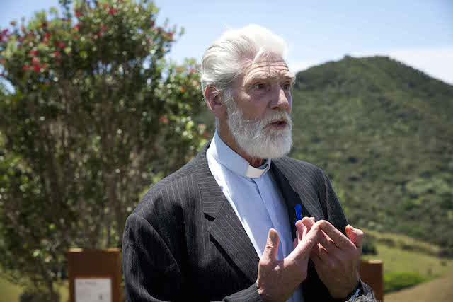
The Rev'd Samuel Marsden Photo: Luci Harrison

One voice that did hit me was when the Rev’d Samuel Marsden stood up. He went to the microphone and said, “Ko Samuel Marsden toku ingoa, my name is Samuel Marsden.” There was applause as he told of his ancestor, his great, great, great, grandfather standing to proclaim the good news of Jesus Christ at Oihi 200 years ago. That was followed by his father 50 year ago. He told us he was doing the same today. I immediately asked myself, "Where is Ruatara?" as I looked out at a sea of white faces.

On reflection, as Samuel Marsden told us his name, he was telling us that the gospel is constant, what changes is the picture of it being told and how it is told. That is the scenario we now have in Aotearoa New Zealand. It is the consistency of the gospel that answers my question of “Where is Ruatara?” He, and others spread themselves across the country and so were present two hundred years on through those who gathered, be they look like white faces at a glance, the story is much deeper as Ruatara worked not just with his own but also Pakeha.
The gathering in 1814 was between two cultures. We are now many faces and many cultures. The picture of 2014 I am sure was not visualized by our predecessors, our three tikanga was not visualised, and 2014 would not have been visualised by earlier Maori bishops. We stood as many faces all part of a constant gospel message.
The kaupapa of Oihi was very much about peace and justice. As we look towards the 175th anniversary of the signing of the Treaty of Waitangi I think it is important that those who gather there are aware of the story at Oihi as that was the foundation that was chosen to build on.

++ Brown Turei

Oihi Bay to the World - Sharing the Peace of Oihi
We gathered on Christmas Day 2014 in Oihi Bay, at the foot of the Marsden Cross. It was a glorious day. The bay would have looked very much as it did 200 years ago. The waves glistened, the slopes were green with vegetation, and the sea birds flew above.

The people gathered were of all ages and backgrounds. It was wonderful to see faces turning expectantly to hear again the message of the angels - of great joy to all people. Two hundred years ago, Samuel Marsden, accompanied by the first missionaries to settle, preached an historic sermon to the Maori. He was enabled by the strength of his friendship with Ruatara. On Christmas Day 2014, the partnership of Bishop Te Kitohi Pikaahu and Bishop Ross Bay was very evident. It echoed that first partnership and spoke powerfully of the strength of partnership in the present context. Beneath the Marsden Cross were leaders of churches, leaders of different denominations. We stood together united in celebrating the coming of the good news of the love of God in Jesus Christ.

In 2014 the good news was told more widely. With the aid of technology there was a bigger crowd who heard the story of Jesus. The service reached homes throughout New Zealand. Archbishop Philip Richardson preached powerfully not only to those gathered in Oihi Bay. There was a passing of Peace amongst the crowd - people reaching out to others. Peace was extended more widely to all viewing throughout New Zealand.
As one of the leaders of the Three Tikanga Church I found much that was moving. One of the most moving moments was when Archbishop Brown Turei gave the final blessing to the people gathered in the Bay and in many other places. A Maori leader was giving the blessing.

We rejoice in the good news of the immense love of God in the coming of Jesus among us 2000 years ago. We rejoice that the good news has reached the shores of New Zealand 200 years ago. We rejoice we are called to share the good news in our context today in partnership with others in our engagement in God's mission.

++Winston Halapua

  Great Joy in the Gospel
  Climate Change
I stood on that little flat space in front of the Marsden Cross at the conclusion of the Christmas Day Bi-centennial service feeling an overwhelming sense of joy. I had just been part of something very special. It had been the work of so many people, but uniquely, in the experience itself, it had become a profound work of the Spirit of God. There was a sense of moment and a sense of place. Large numbers of people had made the journey, the pilgrimage to be there. There was purpose and thanksgiving, but overwhelmingly - a deep joy.  I was surprised by the responses to the service both at Oihi and to the live telecast. Texts and emails came in within minutes; people speaking of how they had been moved and challenged. Several came from people with no church connections who spoke of the Gospel challenging them for the first time.  There is great joy in the Gospel, in the glad tidings, the Good News.  The Gospel of Jesus offers meaning and purpose, vision, direction and discomfort. All of that was very present and real for me on Christmas morning. The gospel speaks in every time and place. We need a renewed confidence and boldness in the proclamation.  The service was one that was three years in the making and its location required planning that is not part of a regular Christmas Service, such as parking in paddocks, shuttle transport and portable toilets. I want to acknowledge the work of Bishop Ross and Bishop Kito, the ecumenical planning group and also the volunteers on the day who made it possible that Oihi was a place for the gospel of the good news to be proclaimed 200 years on from the first proclamation.  ++ Philip Richardson |  | Archbishop Winston was invited to write a prayer for the International Worship Service for the Climate that was held at Copenhagen Cathedral in October. The service marked the release of the report by the United Nations Intergovernmental Panel on Climate Change.  The prayer is written below.  In November Archbishop Winston was part of a delegation with Tagolyn Kabekabe, the Anglican Alliance's Facilitator for the Pacific, to represent the Anglican Communion in Brisbane as part of Oceans of Justice. It was a joint campaign of the global Anglican Alliance, Anglican Overseas Aid and the Australian Anglican Board of Mission.  Archbishop Winston preached in Brisbane at St Augustine's, Hamilton, on the weekend that the leaders of the world's largest economies gathered for the G20 summit.  The delegation was joined other church leaders, agencies, and organisations who were advocating for action on climate change and global poverty and inequality at the G20.  Archbishop Philip Freier issued a statement as the G20 leaders met saying they were gathering at a time of 'great uncertainty' that included fears of economic inequality, potential epidemics and climate change.  "Failure to address these issues of economic security and justice will lead to more international conflict and reduce the possiblity of human flourishing. They cannot be left to fester." he said.

PRAYER FOR CLIMATE CHANGE
BY ARCHBISHOP WINSTON HALAPUA
Loving and Embracing God,
You are God of the Universe and all creation
You create and give life and see that your creation is good.
We praise you for your gift of the Moana [Ancient Polynesian word for ocean] which covers most of the surface of your planet earth.
We thank you for the Oceans of the world.
We thank you for the flowing of the Oceans into one another and around the continents and islands.
We thank you for the life giving of the Oceans,
for the oxygen, food and resources they continually provide
We thank you that the Ocean is home for most species, small and great.
We are people of the Moana (Ocean).
Our ancestors navigated by the stars and crossed the waves to find new homes.
The voice of waves breaking on the reef speaks of your constancy and your love and your care for creation.
May we hear the cries of sea creatures endangered by the selfish greed of humanity.
May there be deep listening to the voice of waters rising to engulf land.
May ears be open to the groaning caused by refusal to honour creation.
May ears be open to suffering caused by a love of power which destroys.
We beat a lali-drum alerting people around the world to the danger of climate change which threatens nature and human life.
We blow a conch – calling for the worship of a life giving God of immense goodness.
Our forbears set out across the Ocean.
We set out on a venture to protect our home – the planet earth;
Help us to challenge short-sighted greed.
Help us to address unjust structures and practices and to change our relationship with creation to one of care.
We affirm our guardianship of the precious gift of creation.
We have a vision, we have courage, we have your guidance.
We have the presence of the Risen One whose power of love is greater than all the power of destruction. Grant that together we may bring peace to our Planet Earth – to its many creatures and its many people. We lotu (pray) in the name of Our God – Creator, Redeemer and Life-Giving Spirit.
Amen.

Trans-Tasman Talks
Special guests at the bicentennial celebrations were Archbishop Philip Freier, the Primate of Australia, and Mrs Joy Freier. The recognition by the Australian Anglican Church of the significance of this celebration in the life of our Church was deeply appreciated.
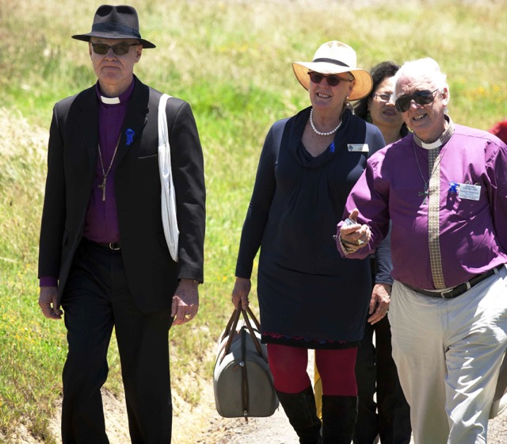
Bishop Richard Randerson(r) shows Archbishop Philip and Joy the pathway through Rangihoua Heritage Park
Photo: Luci Harrison
The visit also enabled a face to face discussion between primates from both Provinces. Speaking face to face is invaluable and discussions explored the potential for greater collaboration between the two Provinces across a number of fields. In particular the possibilities for regular regional gatherings of bishops and other leaders from across the Churches were considered.
The suggestion of an Asia Pacific gathering of bishops was considered as a useful precursor to any future Lambeth gathering. Archbishop Freier had written to the Archbishop of Canterbury suggesting four such gatherings across the Anglican Communion and the Archbishops of Aotearoa, New Zealand and Polynesia have supported this initiative.
Regular video conferencing between the Primates of Australia and this Church will take place throughout this coming year and there will also be opportunities for more face to face conversations. We are delighted at this development as such dialogue and discussion will enhance the mission of the Church and deepen our mutual understanding.

